CLUA_AP DATA ANALYSIS

Eva Wanjiru

2022-09-28

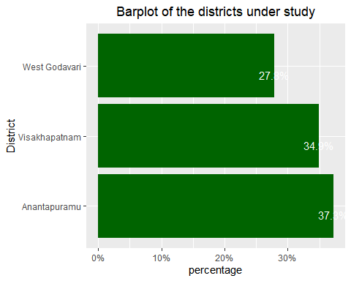

Anantapuramu is the district with the highest count of participants accounting for 46.33% while Visakhapatnam has the least count of participants and accounts for 24.32%.

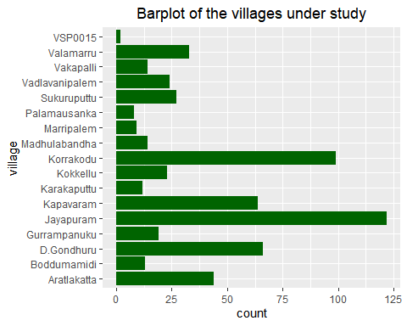

Jayapuram is the village that had the highest count of farms under this study and accounts for 25.58%

## Min. 1st Qu. Median Mean 3rd Qu. Max.   
## 14.69 14.77 16.56 16.44 18.06 18.08

## Min. 1st Qu. Median Mean 3rd Qu. Max.   
## 77.31 77.33 81.69 80.34 82.63 82.67

## Min. 1st Qu. Median Mean 3rd Qu. Max.   
## -72.6 5.2 436.6 394.4 474.1 1038.9

The summary statistics for the latitude,longitude and altitude are given in the output above.

## Min. 1st Qu. Median Mean 3rd Qu. Max.   
## 2.500 4.300 5.925 318.526 16.878 2900.000

There are outliers of the gps accuracy and hence further investigation needs to be done.The maximum value for the gps accuracy is questionable.

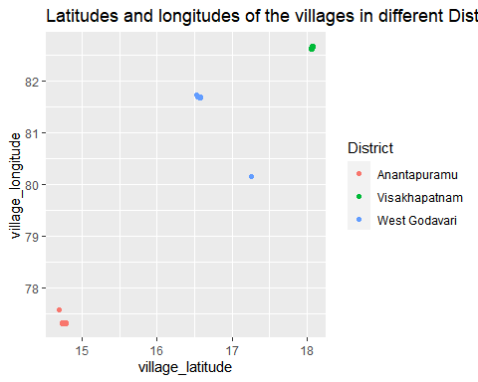

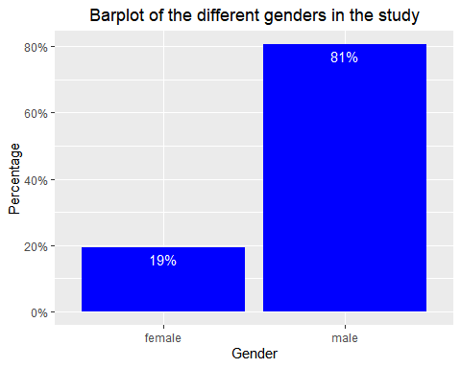

Most of the farmers are males and account for 80.61% of the total population under study.

## Min. 1st Qu. Median Mean 3rd Qu. Max.   
## 21.00 35.00 45.00 44.28 52.00 80.00

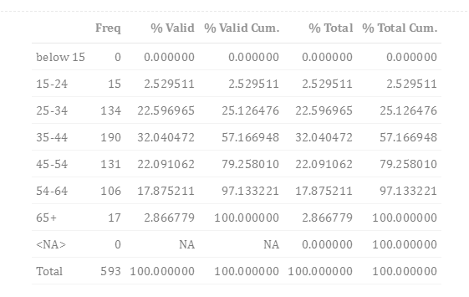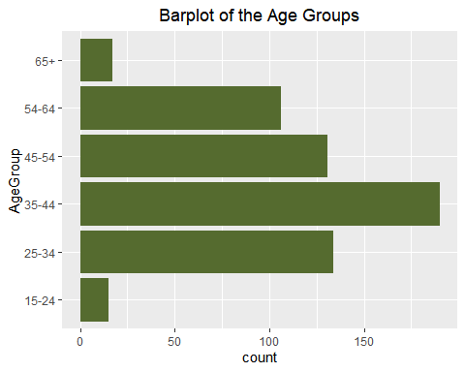

The median age for farmers is 45 but age categories are created to analyse where most farmers lie.Most farmers are aged between 35 and 44 and account for 29.14% of the total population while those aged between 15-24 and above 65 are the minority group and account for 2.94% and 3.14% respectively.

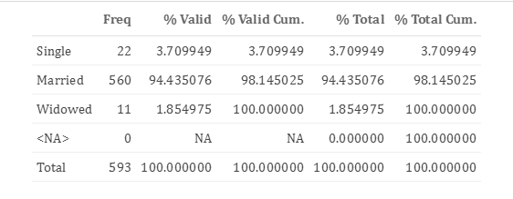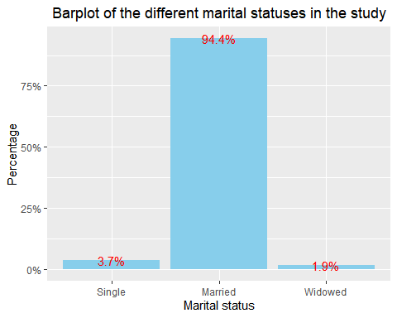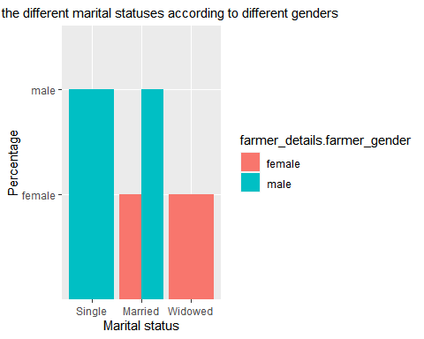

In this study, most of the participants are married and an analysis according to gender is done and the results are shown in the barplot above.The marital status is then grouped according to the gender and the married group consists of more males as compared to females, the widowed category consists of females only and the single category consists of males only.

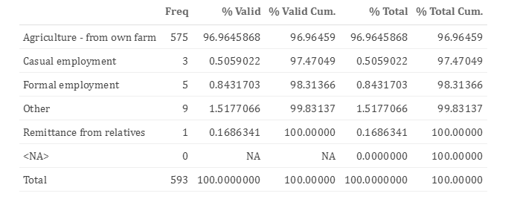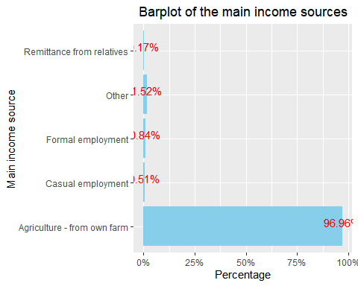

The main source according to most farmers in this study is Agriculture from their own farm which accounts for 96.23%.

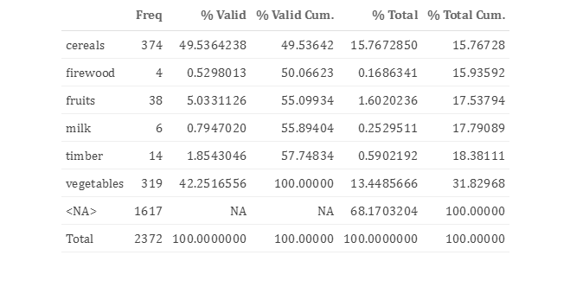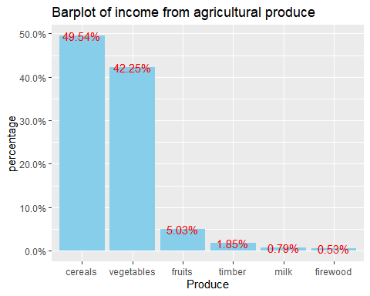

Most farmers(49.21%) produce vegetables in their farms for cash income and the least group(0.63%) produce firewood.

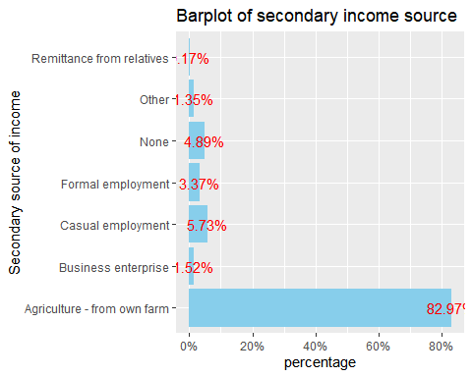

From the graph above, it can be seen that most of the secondary income is from Agriculture in the farmer’s own farms

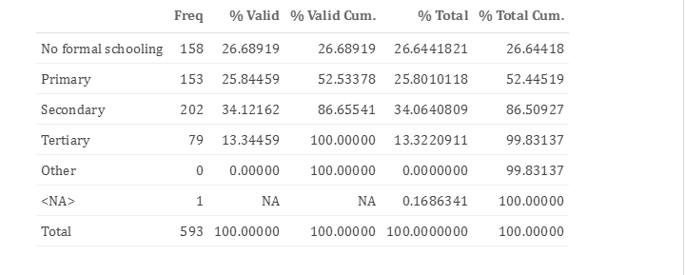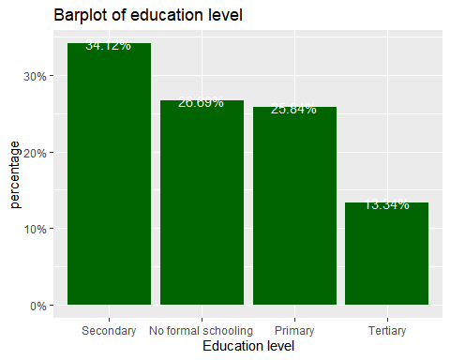

From the output above,most farmers have secondary level information.

## Min. 1st Qu. Median Mean 3rd Qu. Max.   
## 1.000 3.000 4.000 4.184 5.000 15.000

## [1] 12 12 12 12 9 9 10 9 15 15 9 10 12 12 12 13 13 13 13 10 10

## Warning: `fun.y` is deprecated. Use `fun` instead.

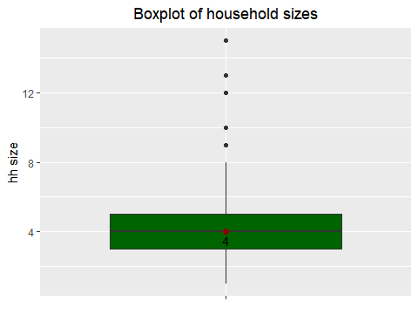 The summary statistics for the household population are given and there are some outliers that is families having a population above 8 members. The boxplot is however shown for easy visualization and it can be seen that the average number of members in a household is 4 members.

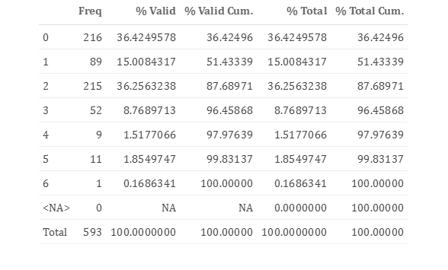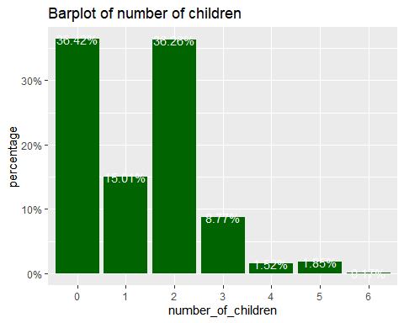

In this study,most families had 2 children accounting for 39.83% of the total population and 32.70% for families with no children while the least 0.21% accounts for families with 6 children.

## Warning: `fun.y` is deprecated. Use `fun` instead.

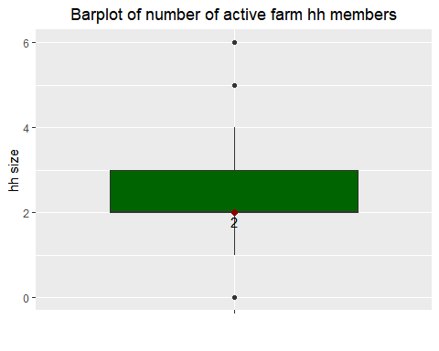

Most families have 2 household members who are active on the farm.

## Min. 1st Qu. Median Mean 3rd Qu. Max. NA's   
## 1.000 1.000 2.000 2.045 2.000 11.000 34

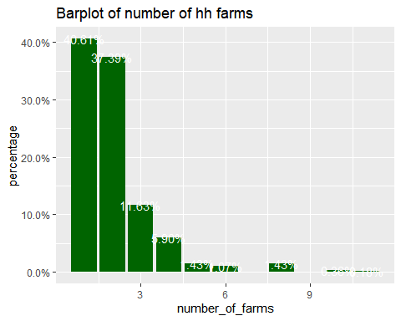

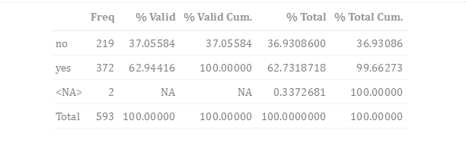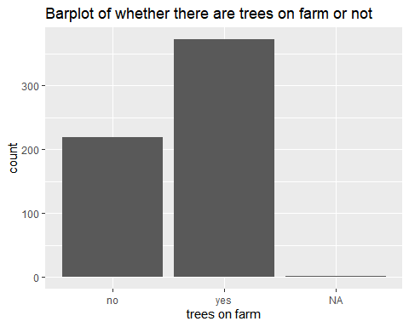

The larger percentage 61.64% of the farmers during this period of study had trees on their farms.

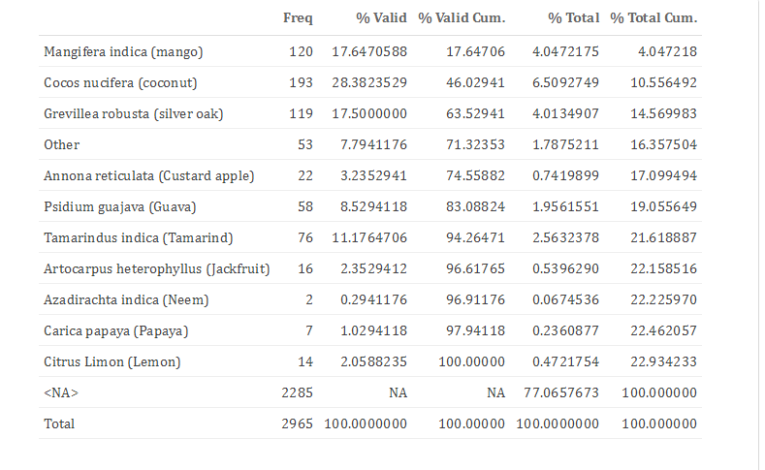

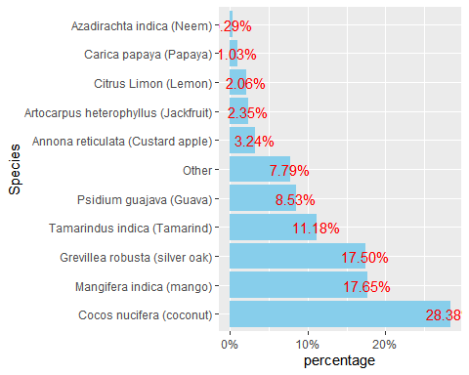

Coconut is the most prevalent tree species and accounts for 38.03% of the total trees available.

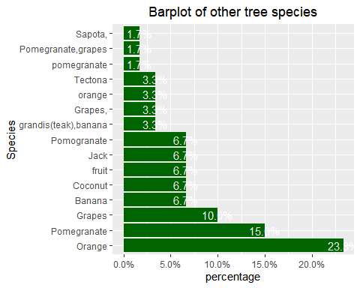

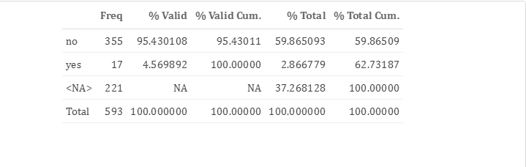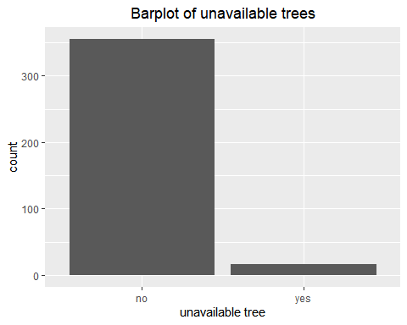

The larger percentage(97.96%) of the farmers during this period of study did not have trees that disappeared from their farms that were there before.

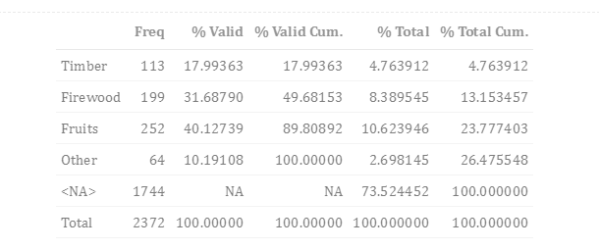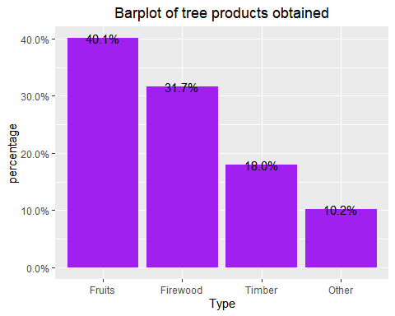

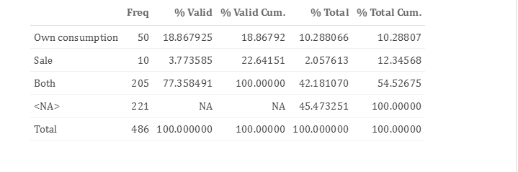

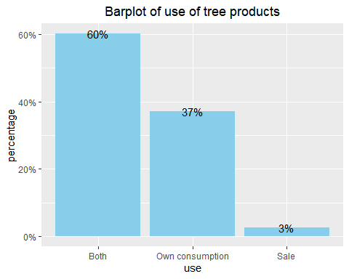

60% of the farmers use the tree products for both own consumption and sale and the least percentage(3%) uses tree products for sale.

There is not much found out about how trees are used but it can be observed that they are used for housing purposes and as wind breakers.

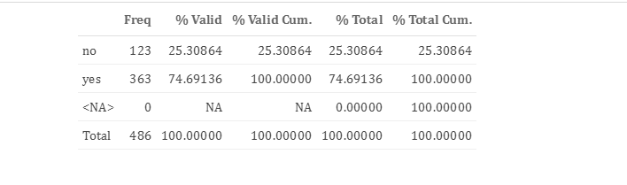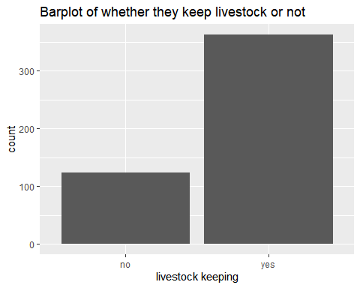

The larger percentage of farmers(74.09%) keeps livestock in their farms.

## Frequencies   
## Livestock_Type$type   
## Type: Factor   
##   
## Freq % Valid % Valid Cum. % Total % Total Cum.  
## --------------- ------ --------- -------------- --------- --------------  
## Cows 226 32.85 32.85 11.63 11.63  
## Buffaloes 158 22.97 55.81 8.13 19.75  
## Goats 33 4.80 60.61 1.70 21.45  
## Sheep 8 1.16 61.77 0.41 21.86  
## Oxen 76 11.05 72.82 3.91 25.77  
## Poultry 187 27.18 100.00 9.62 35.39  
## <NA> 1256 64.61 100.00  
## Total 1944 100.00 100.00 100.00 100.00

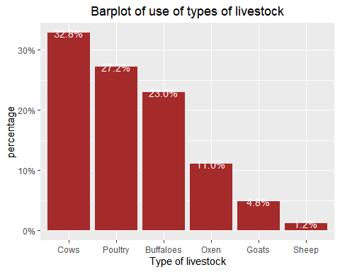

The highest percentage(35.5%) of the farmers keep cows and the least percentage (1.2%) rears sheep.

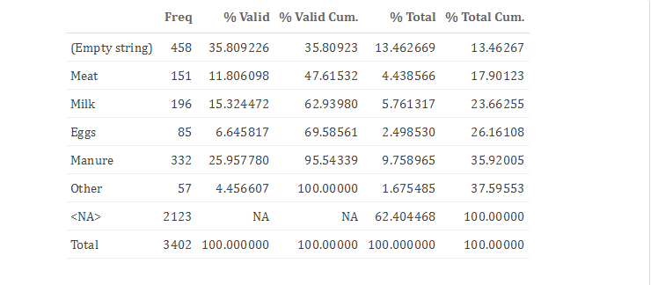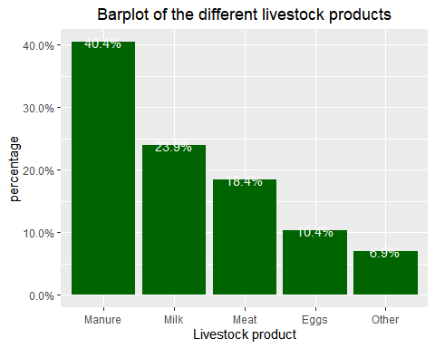

The highest percentage of farmers mainly obtain manure from the livestock kept in the farm and this accounts for 39.6% of the total livestock products.

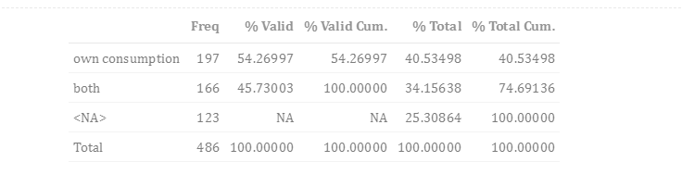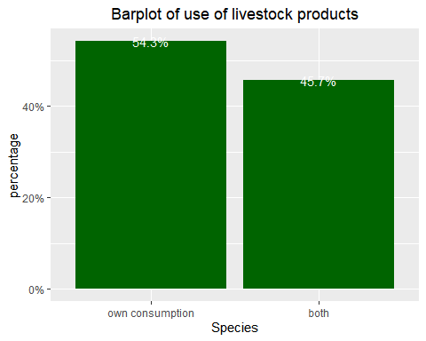

55.94% of farmers which is the higher percentage use livestock products for their own consumption and 44.06% use it for both own consumption and sale.

## Min. 1st Qu. Median Mean 3rd Qu. Max.   
## 0.000 0.500 1.800 1.974 3.000 15.000

## [1] 12 12 15 12 7 12 12 12 12 10 10 8 8 8

There are outliers in the distance from the farm to the nearest main road.

## Min. 1st Qu. Median Mean 3rd Qu. Max.   
## 0.60 6.00 8.00 17.35 32.00 86.00

## [1] 85 86 85 85 80 85 85 85 85 84 80 85 85 85 85 85

There are outliers in the distance to the market.

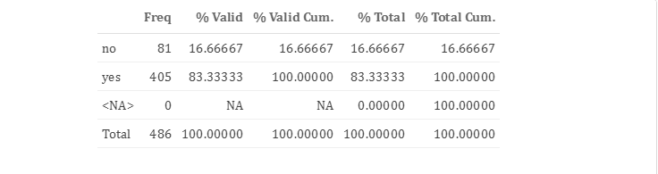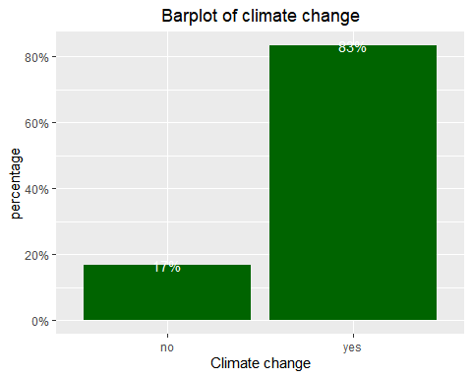

79% of farmers in this study have heard avout climate change.

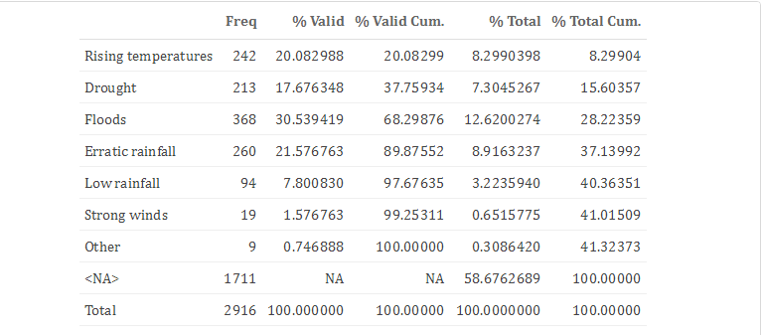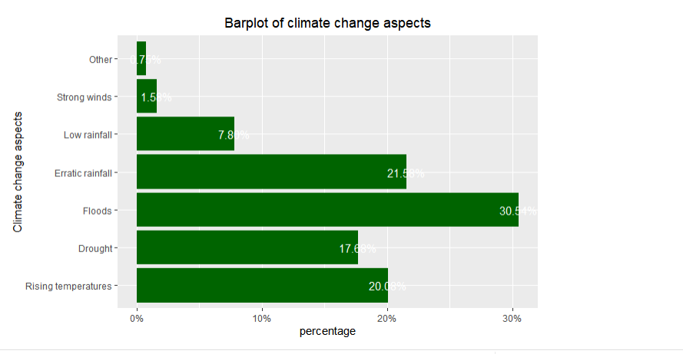

Most farmers 30.13% of the total number of farmers interviewed noted that they have mostly heard of floods followed by drought(21.94%).

## Frequencies   
## df7$group_climatechange.cc_experience   
## Type: Factor   
##   
## Freq % Valid % Valid Cum. % Total % Total Cum.  
## ----------- ------ --------- -------------- --------- --------------  
## no 11 2.72 2.72 2.26 2.26  
## yes 394 97.28 100.00 81.07 83.33  
## <NA> 81 16.67 100.00  
## Total 486 100.00 100.00 100.00 100.00

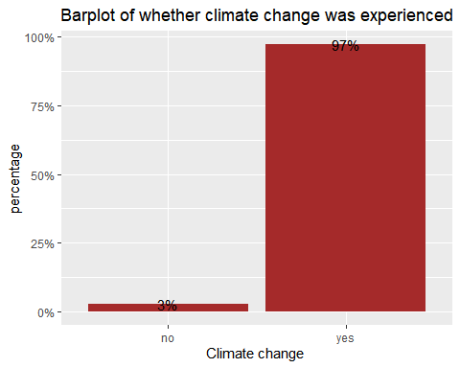

96% of the farmers noted that they experienced climate change and the next code chunk investigates the different types of climate cjhange aspects that were experienced.

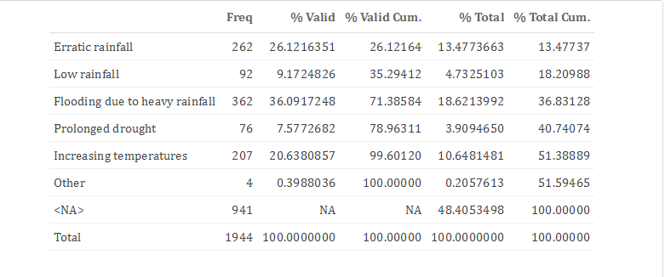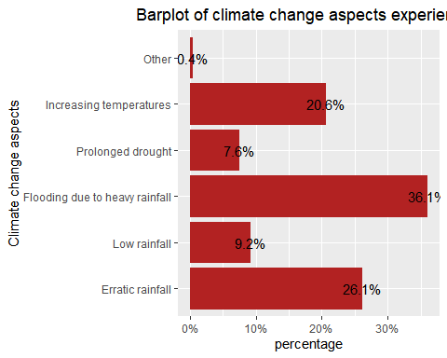

The highest percentage of farmers have experienced floods which accounts for 36.57% of the total climate aspects experienced and the least percentage 0.28% accounts for those that have experienced other climate change aspects.

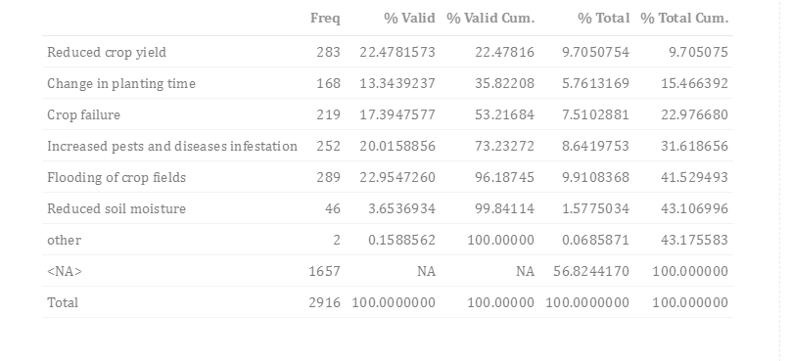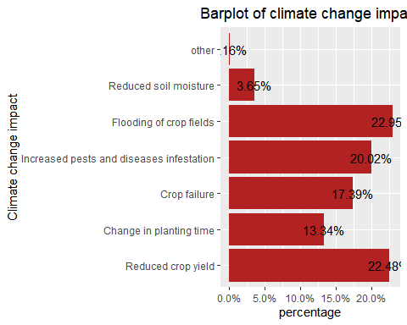

The most prevalent impact of climate change is reduced crop yield which accounts for 22.61% of the total impacts and is closely followed by flooding of crop fields which accounts for 22.27%.

**FURTHER ANALYSIS**

**MAIN INCOME SOURCE** 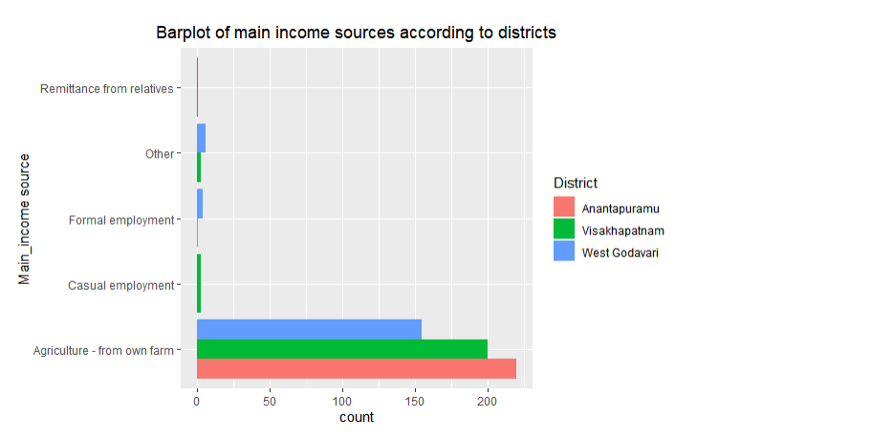

The plot above shows that the main source of income is agriculture from own farm and Anantapuramu has the highest value while West Godavari has the least value.Remittance from relatives is the least common way of getting income in all the districts. **AGRICULTURAL PRODUCE ACCORDING TO DIFFERENT DISTRICTS**

## Frequencies   
## all_agric_produce$type   
## Type: Character   
## Group: District = Anantapuramu   
##   
## Freq % Valid % Valid Cum. % Total % Total Cum.  
## ---------------- ------ --------- -------------- --------- --------------  
## cereals 19 6.99 6.99 2.15 2.15  
## fruits 27 9.93 16.91 3.05 5.20  
## milk 6 2.21 19.12 0.68 5.88  
## vegetables 220 80.88 100.00 24.89 30.77  
## <NA> 612 69.23 100.00  
## Total 884 100.00 100.00 100.00 100.00  
##   
## Group: District = Visakhapatnam   
##   
## Freq % Valid % Valid Cum. % Total % Total Cum.  
## ---------------- ------ --------- -------------- --------- --------------  
## cereals 200 62.31 62.31 24.15 24.15  
## firewood 4 1.25 63.55 0.48 24.64  
## fruits 4 1.25 64.80 0.48 25.12  
## timber 14 4.36 69.16 1.69 26.81  
## vegetables 99 30.84 100.00 11.96 38.77  
## <NA> 507 61.23 100.00  
## Total 828 100.00 100.00 100.00 100.00  
##   
## Group: District = West Godavari   
##   
## Freq % Valid % Valid Cum. % Total % Total Cum.  
## ------------- ------ --------- -------------- --------- --------------  
## cereals 155 95.68 95.68 23.48 23.48  
## fruits 7 4.32 100.00 1.06 24.55  
## <NA> 498 75.45 100.00  
## Total 660 100.00 100.00 100.00 100.00

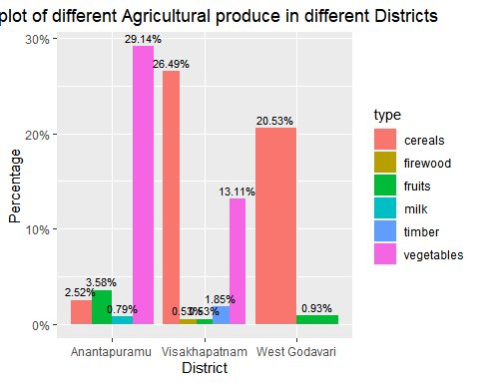

From the plots above, It can be noted that fruits is the least represented agricultural produce in all the districts.In Anantapuramu, there is low production of agricultural produce but it has the highest vegetable production. Visakhapatnam district has the highest production of cereals accounting for 26.49%. West Godavari produces only two types-cereals(20.53%) and fruits(0.93%) and has the least agricultural produce diversity.

**HOUSEHOLD SIZES ACCORDING TO DIFFERENT DISTRICTS** 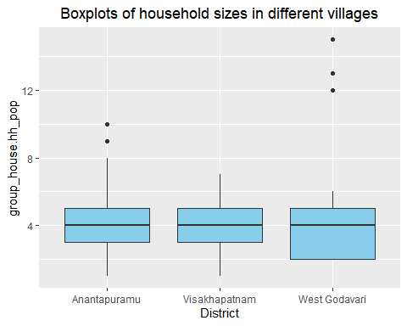

The median number of the total number of household members is 4 in all the districts. There are outlier values in Anantapuramu and West Godavari.In West Godavari, most families are made up of 4 or less people as shown by the boxplot.

## Warning: `fun.y` is deprecated. Use `fun` instead.

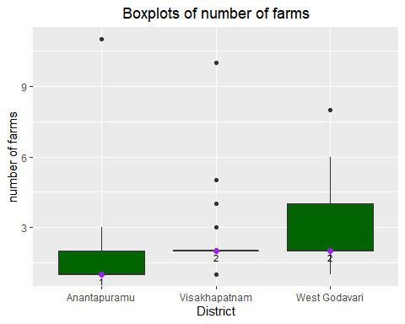

The median number of farms in Anantapuramu is 1 and is 2 in both Visakhapatnam and West Godavari.There are however many outliers in Visakhapatnam.

**TREES** 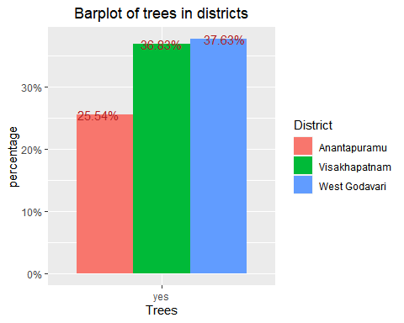

West Godavari has the highest count of trees accounting for 37.63% of all the trees and Anantapuramu has the least count of trees(25.54%).

## Frequencies   
## Tree_species1$type   
## Type: Factor   
## Group: District = Anantapuramu   
##   
## Freq % Valid % Valid Cum. % Total % Total Cum.  
## ------------------------------------------ ------ --------- -------------- --------- --------------  
## Mangifera indica (mango) 9 7.63 7.63 0.81 0.81  
## Cocos nucifera (coconut) 57 48.31 55.93 5.16 5.97  
## Grevillea robusta (silver oak) 0 0.00 55.93 0.00 5.97  
## Other 37 31.36 87.29 3.35 9.32  
## Annona reticulata (Custard apple) 2 1.69 88.98 0.18 9.50  
## Psidium guajava (Guava) 3 2.54 91.53 0.27 9.77  
## Tamarindus indica (Tamarind) 2 1.69 93.22 0.18 9.95  
## Artocarpus heterophyllus (Jackfruit) 0 0.00 93.22 0.00 9.95  
## Azadirachta indica (Neem) 0 0.00 93.22 0.00 9.95  
## Carica papaya (Papaya) 6 5.08 98.31 0.54 10.50  
## Citrus Limon (Lemon) 2 1.69 100.00 0.18 10.68  
## <NA> 987 89.32 100.00  
## Total 1105 100.00 100.00 100.00 100.00  
##   
## Group: District = Visakhapatnam   
##   
## Freq % Valid % Valid Cum. % Total % Total Cum.  
## ------------------------------------------ ------ --------- -------------- --------- --------------  
## Mangifera indica (mango) 100 26.18 26.18 9.66 9.66  
## Cocos nucifera (coconut) 0 0.00 26.18 0.00 9.66  
## Grevillea robusta (silver oak) 119 31.15 57.33 11.50 21.16  
## Other 4 1.05 58.38 0.39 21.55  
## Annona reticulata (Custard apple) 20 5.24 63.61 1.93 23.48  
## Psidium guajava (Guava) 41 10.73 74.35 3.96 27.44  
## Tamarindus indica (Tamarind) 74 19.37 93.72 7.15 34.59  
## Artocarpus heterophyllus (Jackfruit) 12 3.14 96.86 1.16 35.75  
## Azadirachta indica (Neem) 0 0.00 96.86 0.00 35.75  
## Carica papaya (Papaya) 0 0.00 96.86 0.00 35.75  
## Citrus Limon (Lemon) 12 3.14 100.00 1.16 36.91  
## <NA> 653 63.09 100.00  
## Total 1035 100.00 100.00 100.00 100.00  
##   
## Group: District = West Godavari   
##   
## Freq % Valid % Valid Cum. % Total % Total Cum.  
## ------------------------------------------ ------ --------- -------------- --------- --------------  
## Mangifera indica (mango) 11 6.11 6.11 1.33 1.33  
## Cocos nucifera (coconut) 136 75.56 81.67 16.48 17.82  
## Grevillea robusta (silver oak) 0 0.00 81.67 0.00 17.82  
## Other 12 6.67 88.33 1.45 19.27  
## Annona reticulata (Custard apple) 0 0.00 88.33 0.00 19.27  
## Psidium guajava (Guava) 14 7.78 96.11 1.70 20.97  
## Tamarindus indica (Tamarind) 0 0.00 96.11 0.00 20.97  
## Artocarpus heterophyllus (Jackfruit) 4 2.22 98.33 0.48 21.45  
## Azadirachta indica (Neem) 2 1.11 99.44 0.24 21.70  
## Carica papaya (Papaya) 1 0.56 100.00 0.12 21.82  
## Citrus Limon (Lemon) 0 0.00 100.00 0.00 21.82  
## <NA> 645 78.18 100.00  
## Total 825 100.00 100.00 100.00 100.00

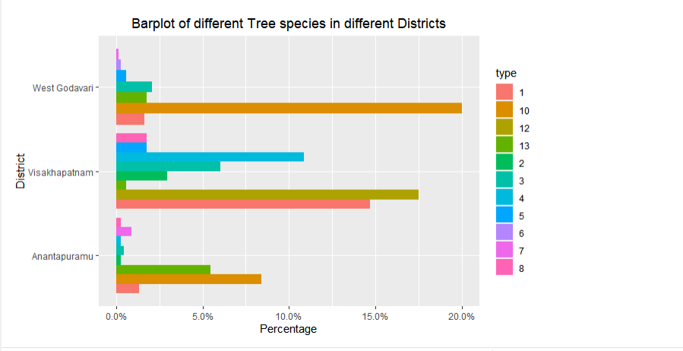

In West Godavari, the most common tree species is coconut, silver oak in Visakhapatnam and coconut in Anantapuramu.

**TREE PRODUCTS**

## Frequencies   
## Tree_products1$type   
## Type: Factor   
## Group: District = Anantapuramu   
##   
## Freq % Valid % Valid Cum. % Total % Total Cum.  
## -------------- ------ --------- -------------- --------- --------------  
## Timber 0 0.00 0.00 0.00 0.00  
## Firewood 0 0.00 0.00 0.00 0.00  
## Fruits 23 95.83 95.83 3.83 3.83  
## Other 1 4.17 100.00 0.17 4.00  
## <NA> 576 96.00 100.00  
## Total 600 100.00 100.00 100.00 100.00  
##   
## Group: District = Visakhapatnam   
##   
## Freq % Valid % Valid Cum. % Total % Total Cum.  
## -------------- ------ --------- -------------- --------- --------------  
## Timber 95 40.08 40.08 13.89 13.89  
## Firewood 77 32.49 72.57 11.26 25.15  
## Fruits 31 13.08 85.65 4.53 29.68  
## Other 34 14.35 100.00 4.97 34.65  
## <NA> 447 65.35 100.00  
## Total 684 100.00 100.00 100.00 100.00  
##   
## Group: District = West Godavari   
##   
## Freq % Valid % Valid Cum. % Total % Total Cum.  
## -------------- ------ --------- -------------- --------- --------------  
## Timber 0 0.00 0.00 0.00 0.00  
## Firewood 91 39.39 39.39 13.79 13.79  
## Fruits 114 49.35 88.74 17.27 31.06  
## Other 26 11.26 100.00 3.94 35.00  
## <NA> 429 65.00 100.00  
## Total 660 100.00 100.00 100.00 100.00

